Friday 08.07.2022
12.00-20.00 Arrival
18.00-22.00 BBQ
19.00-20.00 Welcoming
21.00-.........Music with DJ and Capri Bar 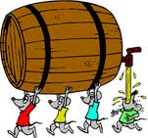
Saturday 09.07.2022
08.00-12.00 Arrival
08.00-10.00 Breakfast buffet
12.00-14.00 BBQ
14:00-17:00 Rodeo Bull contest
All day: spare parts market
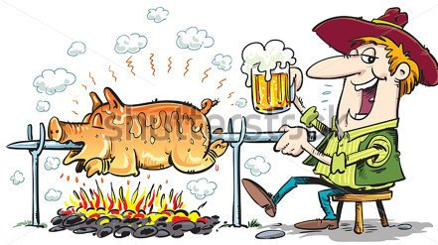
21.00……Appraisal winners ….. Music/dancing with Dj
Sunday 10.07.2022
08.00-10.00 Breakfastbuffet
12.00-14.00 BBQ
Bye Bye

